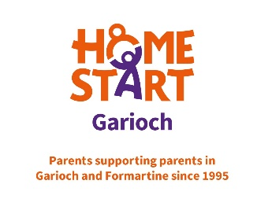
Home-Start Garioch
Getting Involved form

If you need any support completing this form, please contact us.

I am interested in

Personal Details
First Name |  | Last Name

Address
Postcode

Email |  | Contact number

When is a good time to contact you?

Please complete this form and send it back to us and we’ll be in touch for a chat.

Home-Start Garioch has been supporting families in Garioch and Formartine since 1995. With the support of our volunteers who provide one to one support in the family home we make such a positive difference.

All it takes is 2 hours a week.

