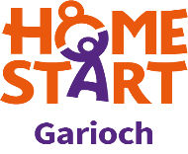

# HOME-START GARIOCH

**VOLUNTEER PROFILE**

A Home-Start volunteer should normally have an understanding of the problems and pleasures of family life.

**Volunteers should:**

* Have a positive attitude to working with of any gender, family status or sexual identity, or who are from any ethnic origin, culture or religion, or who may have a disability
* Demonstrate a sensitive and caring attitude towards others
* Have a non-judgemental attitude
* Be clear about confidentiality and when a confidence remains so, but be able to decide when disclosure of a confidence is essential to the well-being of the child
* Be reliable and understand the importance of reliability to the family
* Have good communication skills including an ability to listen
* Understand the need for support
* Have a warm and open personality and a sense of humour
* Have time and enthusiasm for Home-Start
* Be able to work as a member of a team
* Be prepared to keep records as requested by the scheme.