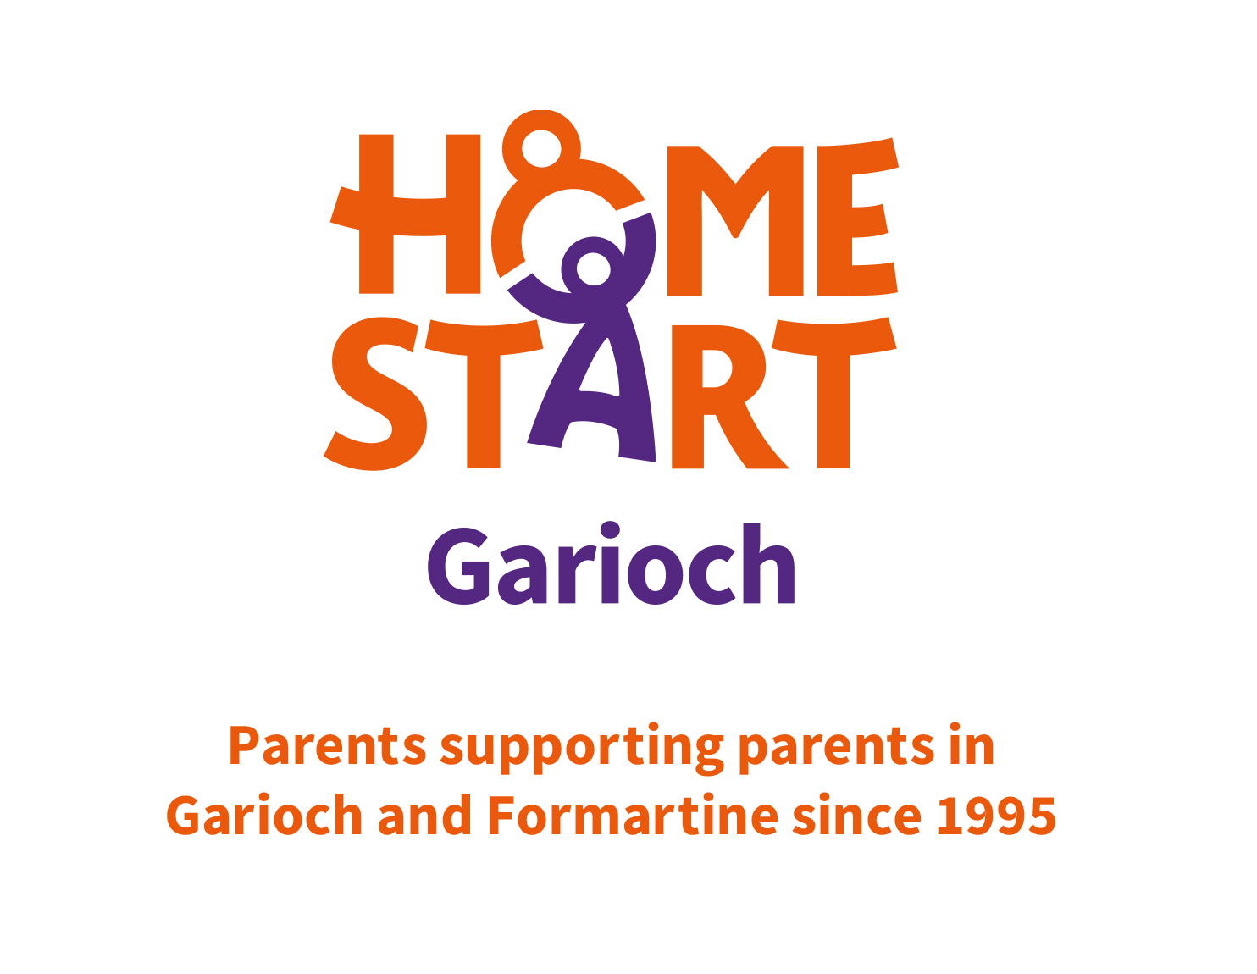
History
Home-Start started in 1973. We were founded by Margaret Harrison who believed that supporting a family was best done in their home where it can be shaped to the needs of the family. She realised that if parents get support and friendship from another parent, they will be better equipped to learn to cope with the many difficulties life can bring, and will be able to give their children the best possible start to their own lives.
Home-Start is a local community network of trained volunteers and expert support helping families with young children through challenging times. That means we’re there for parents when they need us most, because childhood can’t wait.
2022: Nearly 13,500 trained volunteers help over 31,000 families build supportive, loving relatonsips with children every year helping over 53,000 children thrive. 90% of the workforce is made up of volunteers. Only 10% are employees. In comparison to 2021 there has been an increase of 62.4% of children receicving support with the number of families increasing by 56.95%
Today, families face more pressure than every. And the services that could help them are stretched or non-existent. Without stable homes, young children won’t build the foundarions they need to thrive as adults. We work alongside parents to help them regain their confidence.
How we do it: Helping parents be the best they can be. Theres no judgement, just compassionate, confidential help and expert support. Starting in the home, our approach is as individual as the families we work with.
There are over 200 local, independent Home-Starts working in 71% of local authority areas across the UK
Home-start UK website will give you all the information about the history of Home-Start.
https://www.home-start.org.uk/




Home-Start Garioch started in 1995
We focus our service on parents who have at least one child under the age of five.
Our local community appreciates the support that Home-start Garioch gives to parents in the Garioch and Formartine area. The service we offer often lightens the workload of other proffessionals – for example – a health visitor might refer a mother who needs emotional /practical support as she isn’t coping with her baby. The baby isn’t sleeping well, mum is tired struggling with post natal depression with no-one around to support her. The Health Visitor can’t go in and have a cup of tea and a chat, or take the baby for a walk while mum has a shower or catches up on some sleep, but a home start volunteer can.
We work in partnership with health visitors, early years’ practitioners, community groups, mother and baby groups, midwifes, occupational health, and occasionally the Social work department to support families within the community. It is these professionals when visiting a family, working with a family who will identify if a family is struggling identify that we might be able to help, speak to the parent and then with their permission refer to us for support.
Vision and Mission statement for Home-Start Garioch
Home-Start Garioch wants to see a society in which every parent has the support they need to ensure that their children face the future as secure, participating and confident individuals.
Home-Start Garioch offers support, friendship and practical help to parents with young children across the Garioch and Formartine area who are experiencing stress and difficulties. The scheme offers a unique service, recruiting and training volunteers, who are usually parents themselves, to support families who have at least one child under 5, visiting them once a week in their own homes.
Home-Start Garioch offers support to a hugely diverse range of families. Although the area boasts a high level of employment, there still exists some real pockets of deprivation. Families on low incomes face the additional strains of long-distance journeys to work, increased fuel costs, poor and expensive public transport and inaccessibility of affordable childcare. These families also become marginalised as the minority in a relatively affluent community, struggling to make meaningful social networks.
More affluent families are often disadvantaged by rural isolation and can be socially isolated and away from the support of extended family and a network of friends.
As an organisation we provide initial and ongoing training to our volunteers with regular support and supervision. Families are referred for support from mainly statutory services for support. A co-ordinator will then meet with the family to discuss how best we can support them to achieve positive outcomes. The coordinator will match the family to a volunteer, they may sign post the family to another service or support the family to access a service. Families are reviewed 3 monthly to track their journey of change. Regular contact with statutory services to ensure appropriate referrals are made.
How have we made a difference to the community so far?
We support families in Garioch and Formartine, Turriff, Huntly and the surrounding areas. A georgraphical area which is predominantly rural and covers over 700 square miles.
Last year we support 176 children thanks to the 75 volunteers who visit the families we support.
Our charity differs from others in that we are non-judgemental about the families we support; our charity is non-statutory which means that people find it easy to approach us for help and accept help from.
Referrers tell us;
“The support offered to families is invaluable and frees up Health Visitors to concentrate on the health needs of the family.”
“The support they provide is a continuation of what we do. It’s very helpful to me when a family fight against me (because I’m a Social Worker) but happily accept and follow the same advice from their volunteer. That really is working together!”
From statistics taken at the start and end of support, parents have reported that
96% feel less isolated.
95 % have improved self-esteem.
91% are better able to cope with their mental ill health.



Financial
Do you have any major sponsors?
- No, but we do receive a yearly donation of around £5,000 from The Garioch Charities Shop.
Do you receive government funding?
- We receive approximately 26% of our funding from Aberdeenshire Council.
How do you fundraise?
- We have a fundraising group who meet bi-monthly to plan fundraising events. We hold many events throughout the year large and small in Inverurie, Ellon and Westhill, Huntly and Foggie.
For larger amounts we apply to Trust Funds for grants.
This year we have received money from The Bank of Scotland Foundation and The Robertson Trust for 3 years. We have also applied to other Foundations for smaller amounts.

How much money is spent on running the charity (administration)
- It costs approximately £130,000 per annum to run the scheme at the present time.
How many people work at the charity?
- We have 6 paid staff members: Scheme manager working 35 hours per week, 4 co-ordinators working 18 hours per week and an administrator working 20 hours per week.
- We have between 70 and 80 home-visiting volunteers at any one time and 11 Trustees who oversee the management of the scheme.

Volunteers section

Selection process for volunteers
We encourage our existing volunteers to ask their friends and family members to consider volunteering
Advertisements on our Facebook page, in the local press, posters which are put up in the community centres and notice boards,
We hold information events for potential volunteers
Volunteers usually are parents themselves as their experience is very valuable and relevant as a Home-start volunteer. The qualities we look for in a volunteer is a non-judgemental person who is caring and willing to support someone in lots of different situations, practically and emotionally.
There are 9 sessions contained within the training which includes Introduction to Home-Start and the Role of a Home-Visiting volunteer. Values and Attitudes, Listening and Communication, Supporting Parents, Mental Health Awareness, Domestic Abuse, Meeting the Needs of Children, Protecting and Safeguarding Children and Vulnerable Adults, Confidentiality,
A PVG check is done and 2 written references are obtained.
Once a volunteer has covered the complete course, they have a final interview and are then matched with a family who needs support
Volunteers are asked to visit the office for support and supervision every 6-8 weeks
Volunteers visit the families up to 2 hours at a time on a weekly basis.
Specific support might be;
Looking after the children by playing, reading to and interacting with them, feeding them at meal times, looking after them while parents go shopping /go to appointments or have some free time to themselves.
Listening and really empathising with parents who have emotional problems or mental health issues;
Accompanying the parent and children to baby groups or to other community groups to increase self-confidence and self-esteem.
Supporting the parent to attend appointments, either by being an extra pair of hands or helping to transport them
Volunteers build up a lovely relationship with their families – here are some quotes from families who have received support.
“Facing potentially lifesaving surgery has had a huge impact on my mental health. Home-Start Garioch provided me with support with the Mellow Bumps programme while I was pregnant and then with a home visiting volunteer. She accompanies me to my hospital appointments, plays with the girls so I can take time out and I guess most importantly is there for me when I need time to cry, to share my fears which is hard to do with friends and family who are also affected by my illness”
“I remember telling my coordinator that I was happy being isolated and that I didn’t need to go to groups. Really, I was terrified that the other mums would judge me. My volunteer told me about some smaller groups and came along with me. I actually found out that I liked it. I have made some friends and feel confident to go to the groups on my own. It’s important for Ava to have children her age to play with instead of just me and I was feeling guilty that my lack of self-esteem was preventing me taking her. She has come on so much”
“General support coping with mental health issues and physical disability without judgement. This is an invaluable help service, without it and the people involved I would be screwed. I can’t say how much it helps all I can say is thank you.”
“It was short, but it came at just the right time”
Supporting volunteers
We see our volunteers face to face once every 6-8 weeks for support and supervision. To check that they are happy with the support they are giving to the family. To identify if the volunteer requires additional support or training. And to make sure that their contribution is valued
We hold Network and Development days. Sometimes these are informal when volunteers chat and have a coffee. Others are specifically run to give information on the services in the area.
These have included,
Library staff – talks about the importance of books etc
Foodbank Inverurie branch.
SensationALL – support for children with Autistic spectrum disorders
First Aid training



Volunteers tell us that volunteering for Home-Start Garioch has;
Increased their Personal Development
Increased their Skills Development
Improved their Health and Well-being
They now have a greater awareness of Diversity and Inclusion
Increased their Friendships and contacts in the Community
Rewarding our volunteers, staff and families
We have a Christmas lunch every year with the board, staff and volunteers.
We have a summer outing for the families and a Christmas Party.



